|  |  |  |  |  |
| --- | --- | --- | --- | --- |
| http://chart.apis.google.com/chart?cht=qr&chs=360x360&chl=http://www.urbansurvivalfitness.com/Home/Special-Events |  | |  | | --- | | Can You Survive  The Urban Survivor Obstacle Course? | | Issue Date | |
|  |  |  |
| **will you be the next urban survivor? Will you be the first urban surivor?** |  | www.urbansurvivalfitness.com |

**The Urban Survivor Obstacle Course was created by Master Survival Specialist, Jeffrey McMillan and his team to test your ability to survive urban obstacles by running, climbing, tire flipping crawling and pulling your way through the 4 acre course.   You will be tested in ways you never thought possible.  Get dirty, be tough and test your physical and mental strength, stamina and overall fitness. Overcome the obstacles in front of you and do what it takes to CROSS THE FINISH LINE and become an Urban Survivor!**

**CAN YOU SURVIVE?**

**Saturday Sept 15, 2012**

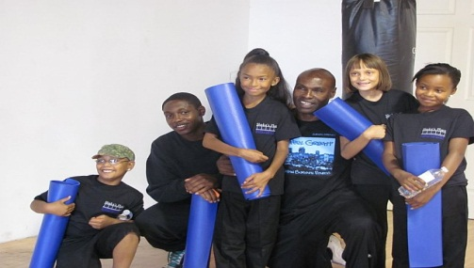

**Help Combat Childhood Obesity**

**Urban Survival Fitness is hosting the Urban Survivor Obstacle Course to raise money to fund programs which will**

**Combat Childhood Obesity.**

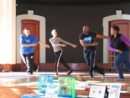

**SPONSOR AN OBSTACLE**

**BE THE FIRST TO COMMIT TO SPONSORING AN OBSTACLE AND GET FIRST CHOICE. cALL 720-838-4401 FOR MORE INFORMATION**

**Quick Facts...**

* Overweight children have an increased risk of being overweight as adults.
* Genetics, behavior, and family environment play a role in childhood obesity.
* Childhood obesity increases the risk for certain medical and psychological conditions.

# **HELP COMBAT CHILDHOOD OBESITY**

**Do you want something different from a marathon or triathlon?  This obstacle course will put all those challenges to shame.  Let the obstacle course be your new addiction.  Instead of long trails interspersed with only a few obstacles, join us in a unique configuration of some old favorites mixed with new obstacles, strategically designed over a 4 acre course, in a way that catapults your experience to the next level. All this while you have the time of your life competing with like-minded individuals to become the next URBAN SURVIVOR.**

.

**Urban Survivor Obstacle Course**

**Help Us Combat Childhood Obesity**

**Come face the ULTIMATE CHALLENGE - alone or form a team of 4 - at the First Annual Urban Survivor Obstacle Course.**

When: **Saturday, September 15, 2012**

Where: **3540 East 31st Avenue, Denver, CO 80205**

Why: To help fund programs to **Combat Childhood Obesity**

**Costs:**

**Individual fees: Prior to August 15th $30**

**Prior to September 15th $35**

**At the Door $40**

**Awards go to 1st, 2nd and 3rd place winners based on time**

**Team fees: Prior August 15th $25 each person**

**(Teams of 4 only) Prior to September 15th $30 each person**

**At the Door $35 each person**

**Family Fun Run begins at 8AM - First timed event begins at 9AM**

**Award goes to the 1st place team – Team with the best time through the course.**

**Children under 18 free – Kids playground and face painting at the event.**

**Spectators:**

**Adults $5 at the door – Enjoy live music, DJ and Food & Drinks.**

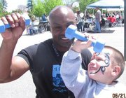 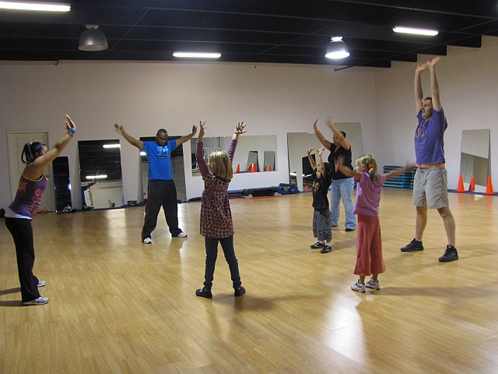

**Visit our Special Events page at** <http://www.urbansurvivalfitness.com/Home/Special-Events>  **to register you and/or your team**

**and to get updated information or call us at 720-838-4401**

|  |
| --- |
|  |